

Capstone Project Report
Report 4 – Software Design Document

– HoChiMinh, January 2025 –

Contents
I. Record of Changes 2
II. Software Design Document 3
1. System Design 3
1.1 System Architecture 3
1.2 Package Diagram 7
2. Database Design 10
3. Detailed Design 16
3.1 Manage Pricing 16
3.2 Manage Booking 18
3.3 Manage Trip 24

I. Record of Changes
Date | A*  M, D | In charge | Change Description
*A - Added M - Modified D - Deleted

II. Software Design Document

1. System Design

1.1 System Architecture
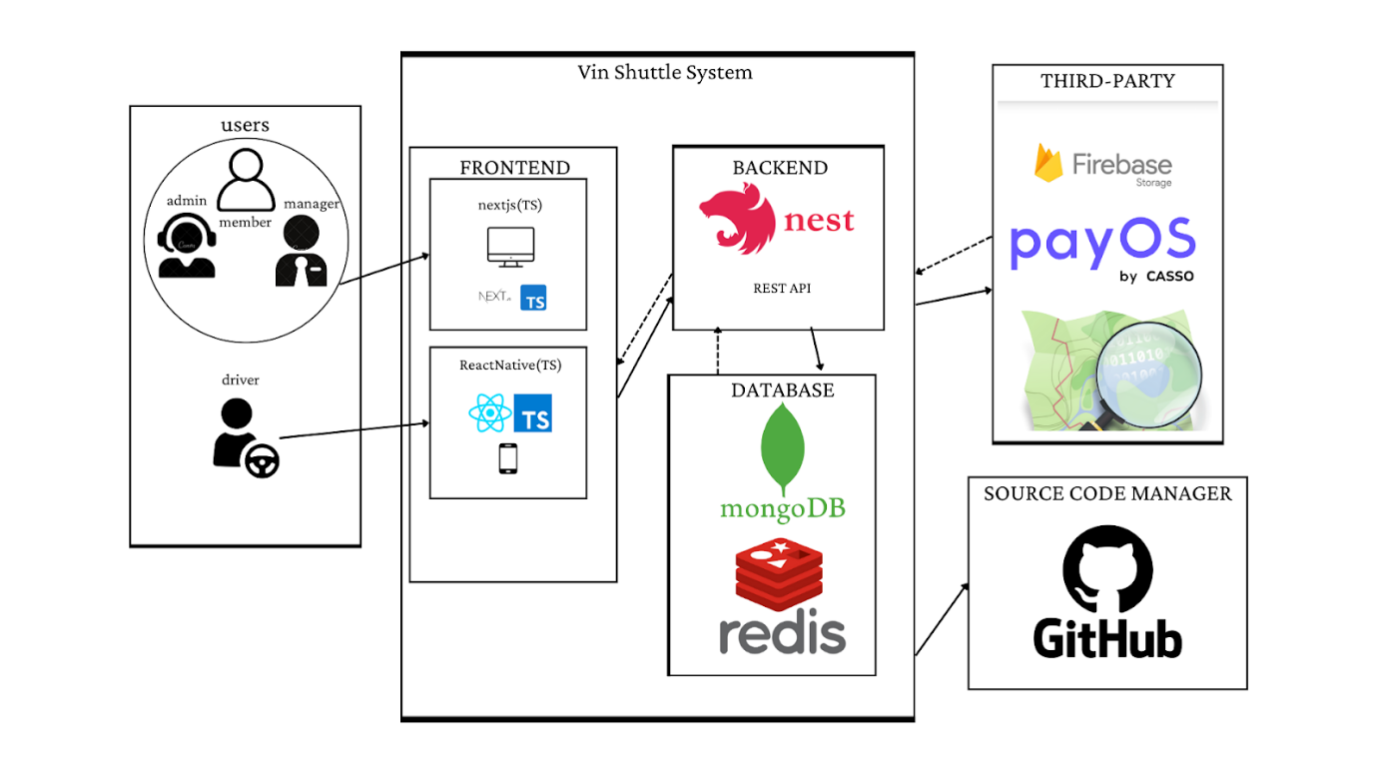

1.1.1. API architecture diagram
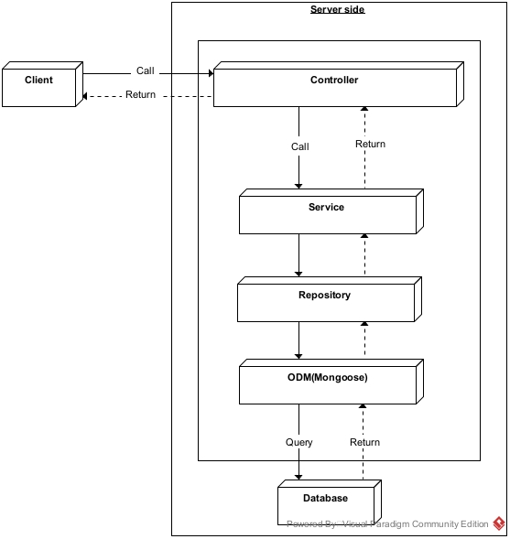

1.1.2. Mobile Application architecture diagram
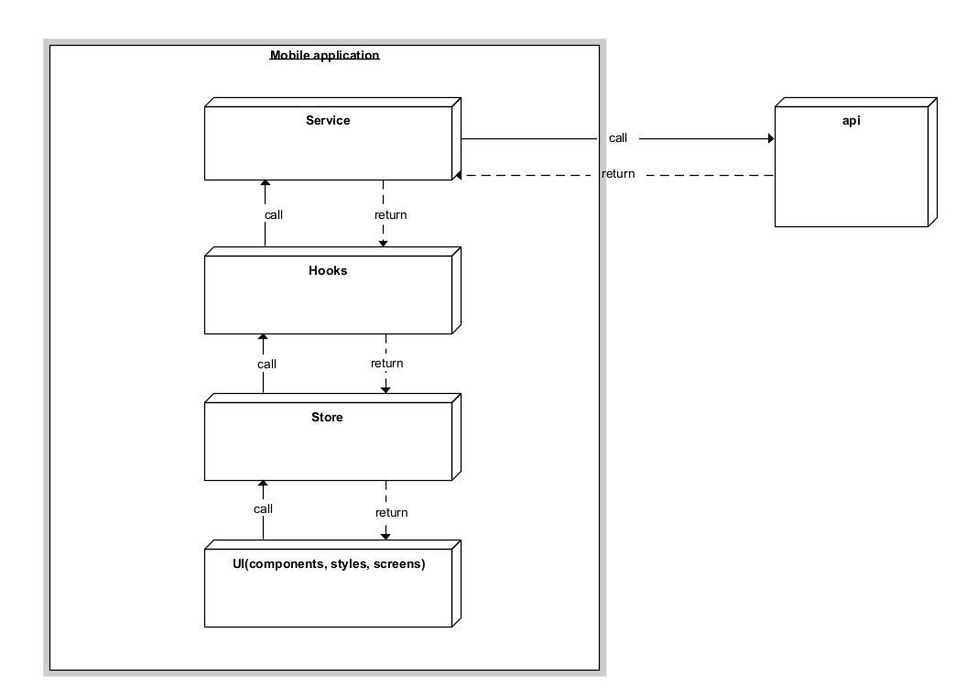

1.1.3. Web Application architecture diagram
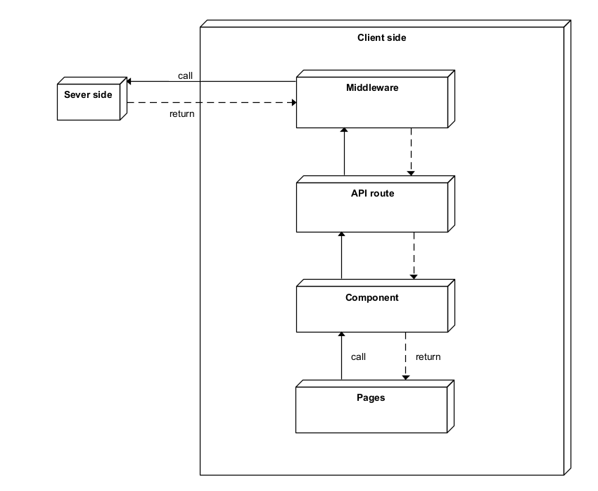

1.2 Package Diagram

1.2.1 Web API package diagram
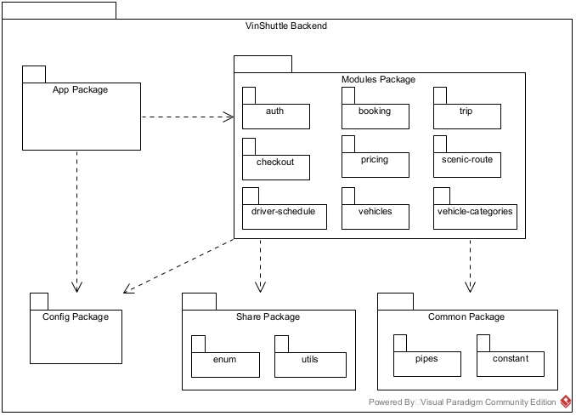

1.2.2 Web application package diagram

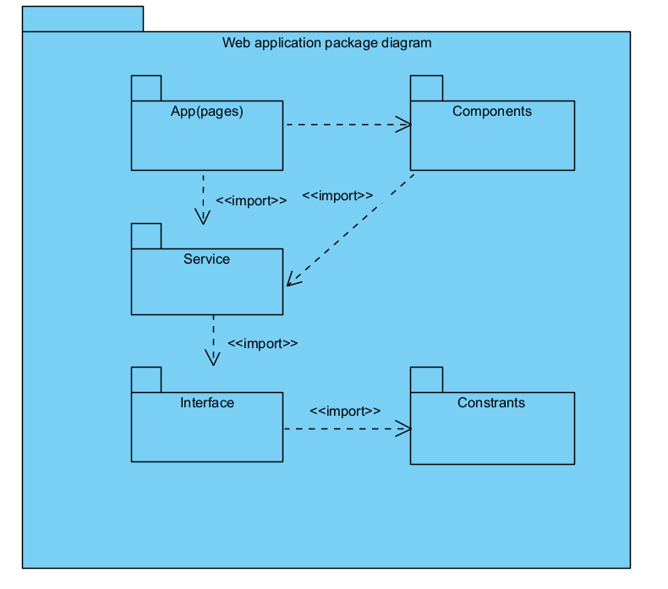

1.2.3. Mobile application package diagram
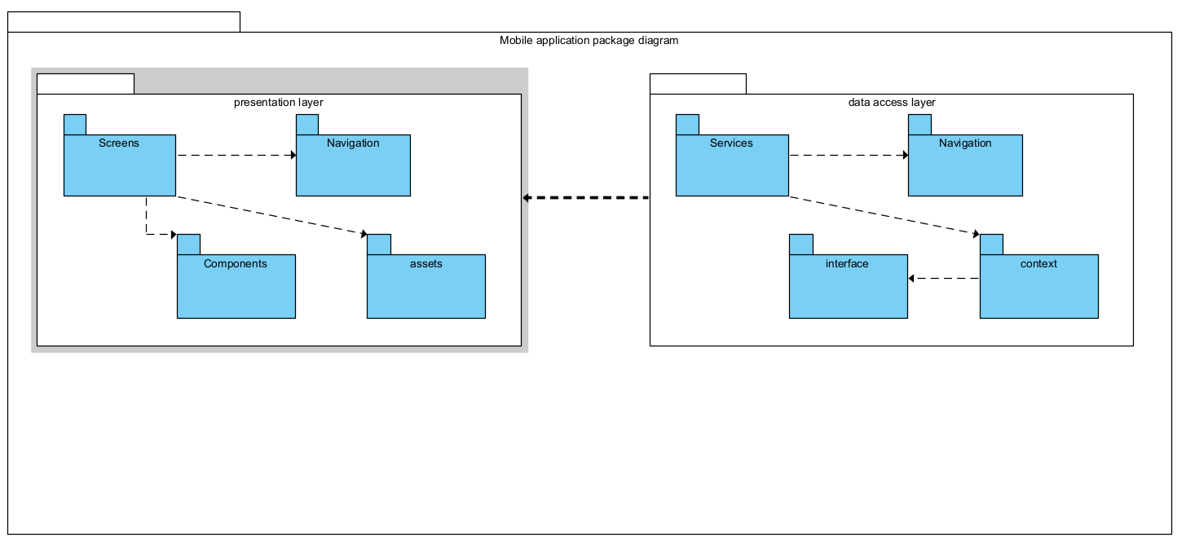

Package Descriptions
No | Package | Description
01 | Web API package diagram | This diagram provides an overview of the package organisation for a Web API-based backend service.
02 | Web application package diagram | This diagram illustrates the package structure for a web application that includes both backend and frontend components.
03 | Mobile application package diagram | This diagram represents the package structure of a mobile application, organising UI, data, and service layers to support seamless user experiences and efficient data handling.

2. Database Design
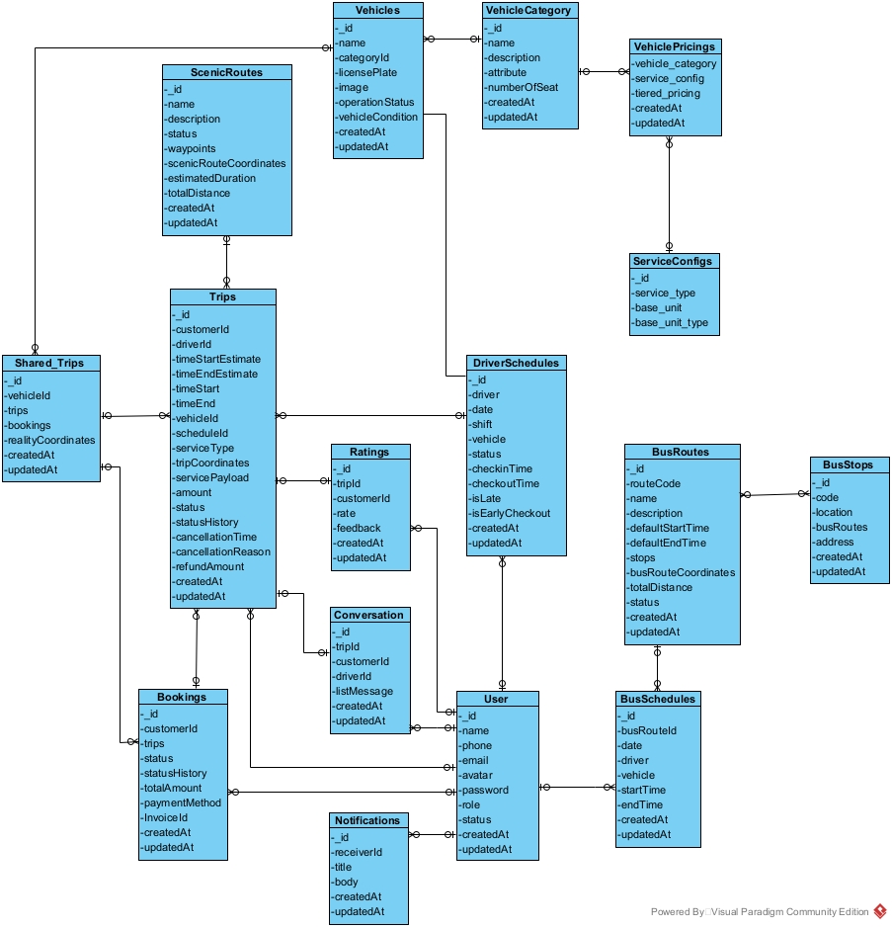
Table Descriptions
No | Table | Description
01 | ScenicRoutes | Describe ScenicRoutes in the system
02 | Vehicles | Describe Vehicles in the system
03 | VehicleCategory | Describe VehicleCategory in the system
04 | VehiclePricings | Describe VehiclePricings in the system
05 | Shared_Trips | Describe Shared_Trips in the system
06 | Trips | Describe Trips in the system
07 | Ratings | Describe Ratings in the system
08 | DriverSchedules | Describe DriverSchedules in the system
09 | ServiceConfigs | Describe ServiceConfigs in the system
10 | Bookings | Describe Bookings in the system
11 | Conversation | Describe Conversation in the system
12 | users | Describe users in the system
13 | BusRoutes | Describe BusRoutes in the system
14 | BusStops | Describe BusStops in the system
15 | Notifications | Describe Notifications in the system
16 | BusSchedules | Describe BusSchedules in the system

Attribute Data Dictionary

Entity name | Attribute | Description | Domain | Null
ScenicRoutes | _id | Unique identification system ScenicRoutes | ObjectId | NO
 | name | ScenicRoutes name | String | NO
 | description | ScenicRoutes description | String
 | status | ScenicRoutes status | String
 | waypoints | waypoints of routes | Array
 | scenicRouteCoordinates | scenicRouteCoordinates | Array
 | estimatedDuration | Estimated time to complete the route | Double
 | totalDistance | total Distance of route | Double
 | createdAt | create time | Date
 | updatedAt | update time | Date
Vehicles | _id | Unique identification system Vehicles | ObjectId
 | name | Vehicles name | string
 | categoryId | Vehicle category identifier, associated with the vehicle category | ObjectId
 | licensePlate | license plate Vehicles | string
 | isActive | Vehicle operating status | boolean
 | status | Condition of the vehicle | string
 | createdAt | create time | date
 | updatedAt | update time | date
VehicleCategory | _id | A unique identifier for each vehicle category. | ObjectId
 | name | The name of the vehicle category | string
 | description | A brief description of the vehicle category, explaining its characteristics or usage. | string
 | numberOfSeat | The standard number of seats available in vehicles belonging to this category | int
VehiclePricings | _id | Unique identifier for the vehicle pricing entry | ObjectId
 | vehicle_category | Reference to the vehicle category being priced | ObjectId
 | service_config | Configuration details of the service pricing | ObjectId
 | tiered_pricing | Pricing structure based on different tiers | Array
 | createdAt | Timestamp when the pricing record was created | Date
 | updatedAt | Timestamp when the pricing record was last updated | Date
Shared_Trips
Trips | _id | Unique identifier for the trip
 | customerId | Reference to the customer who booked the trip
 | driverId | Reference to the driver assigned to the trip
 | timeStart | Actual start time of the trip
 | timeEnd | Actual end time of the trip
 | timeStartEstimate | Estimated start time of the trip
 | timeEndEstimate | Estimated end time of the trip
 | vehicleId | Reference to the vehicle used for the trip
 | scheduleId
 | serviceType
 | servicePayload
 | amount
 | status
 | tripCoordinates
 | statusHistory
 | createdAt
 | updatedAt

3. Detailed Design

3.1 Manage Pricing

3.1.1 Pricing Class Diagram
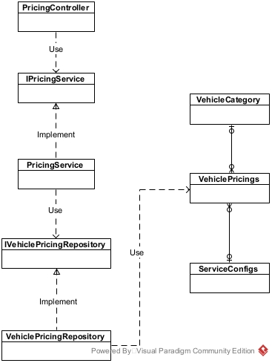
3.1.2 Create Pricing Sequence Diagram
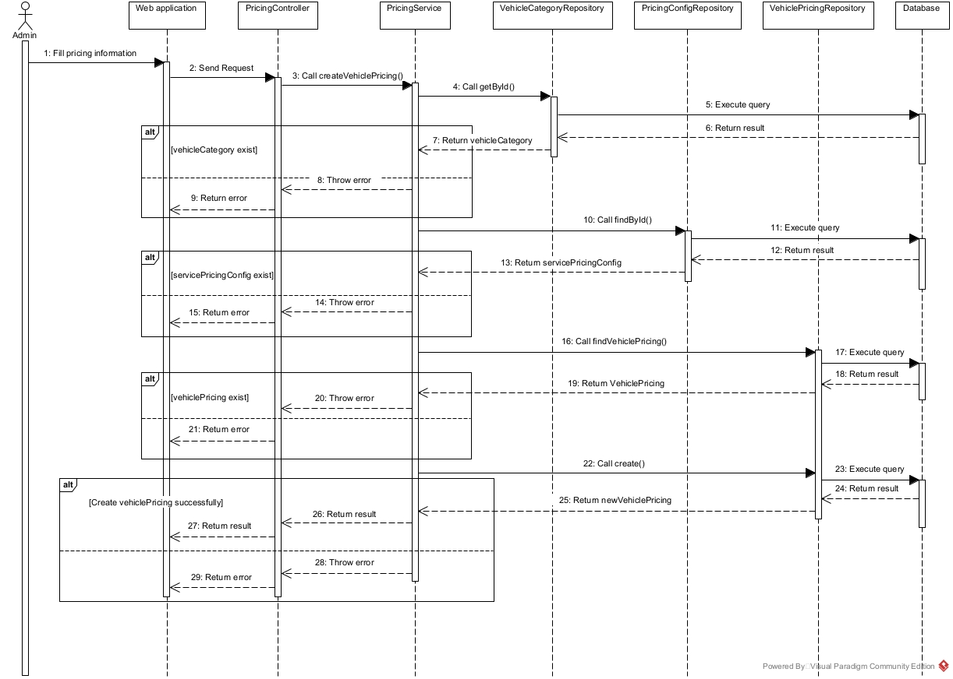

3.1.3 Update Pricing Sequence Diagram

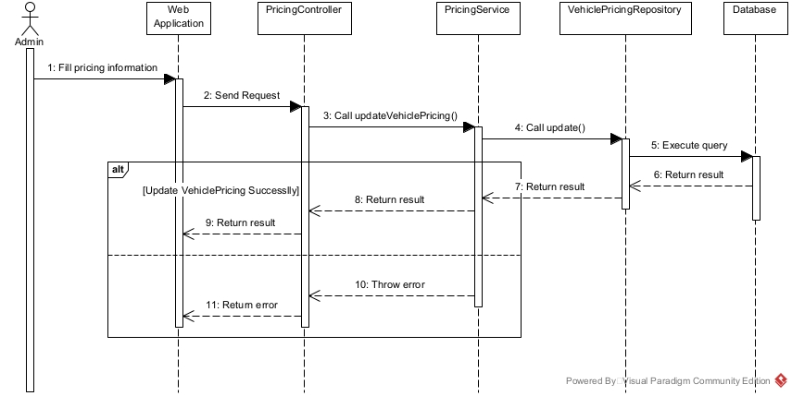

3.2 Manage Booking

3.2.1 Booking Class Diagram

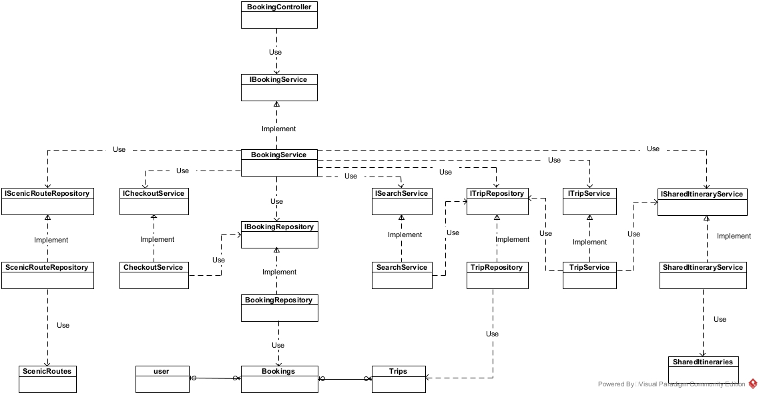

3.2.2 Booking Activity Diagram
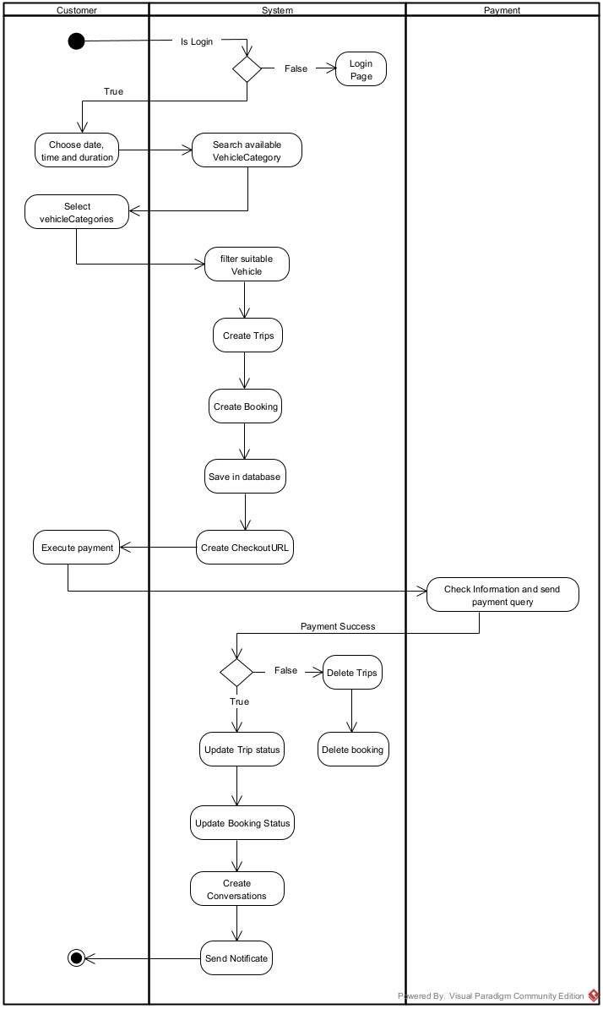
3.2.3 Create BookingHour Sequence Diagram

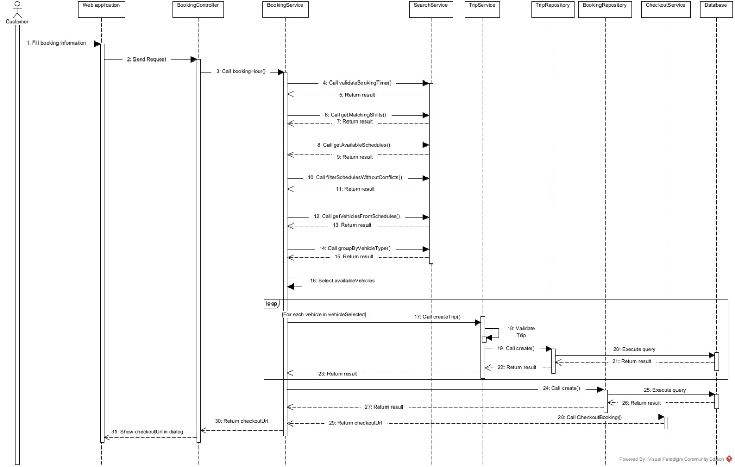

3.2.3 Create BookingScenicRoute Sequence Diagram
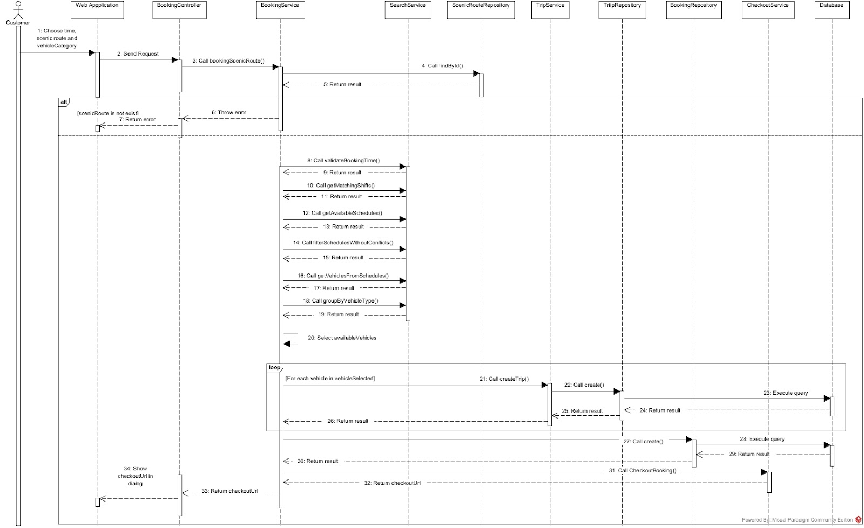

3.2.4 Create BookingDestination Sequence Diagram
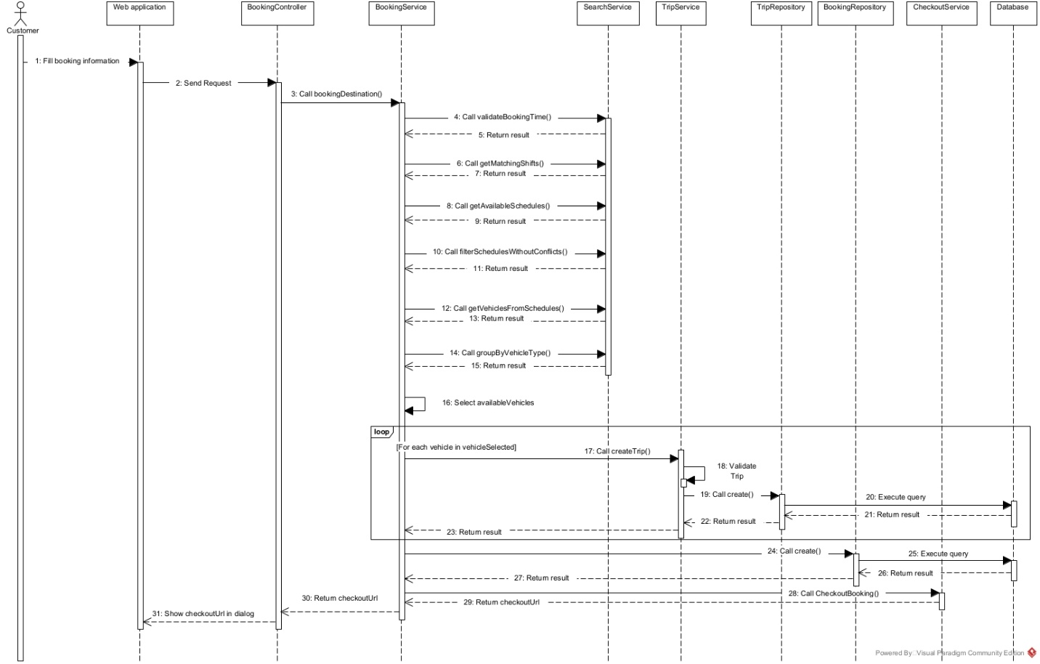

3.2.5 Create BookingShared Sequence Diagram
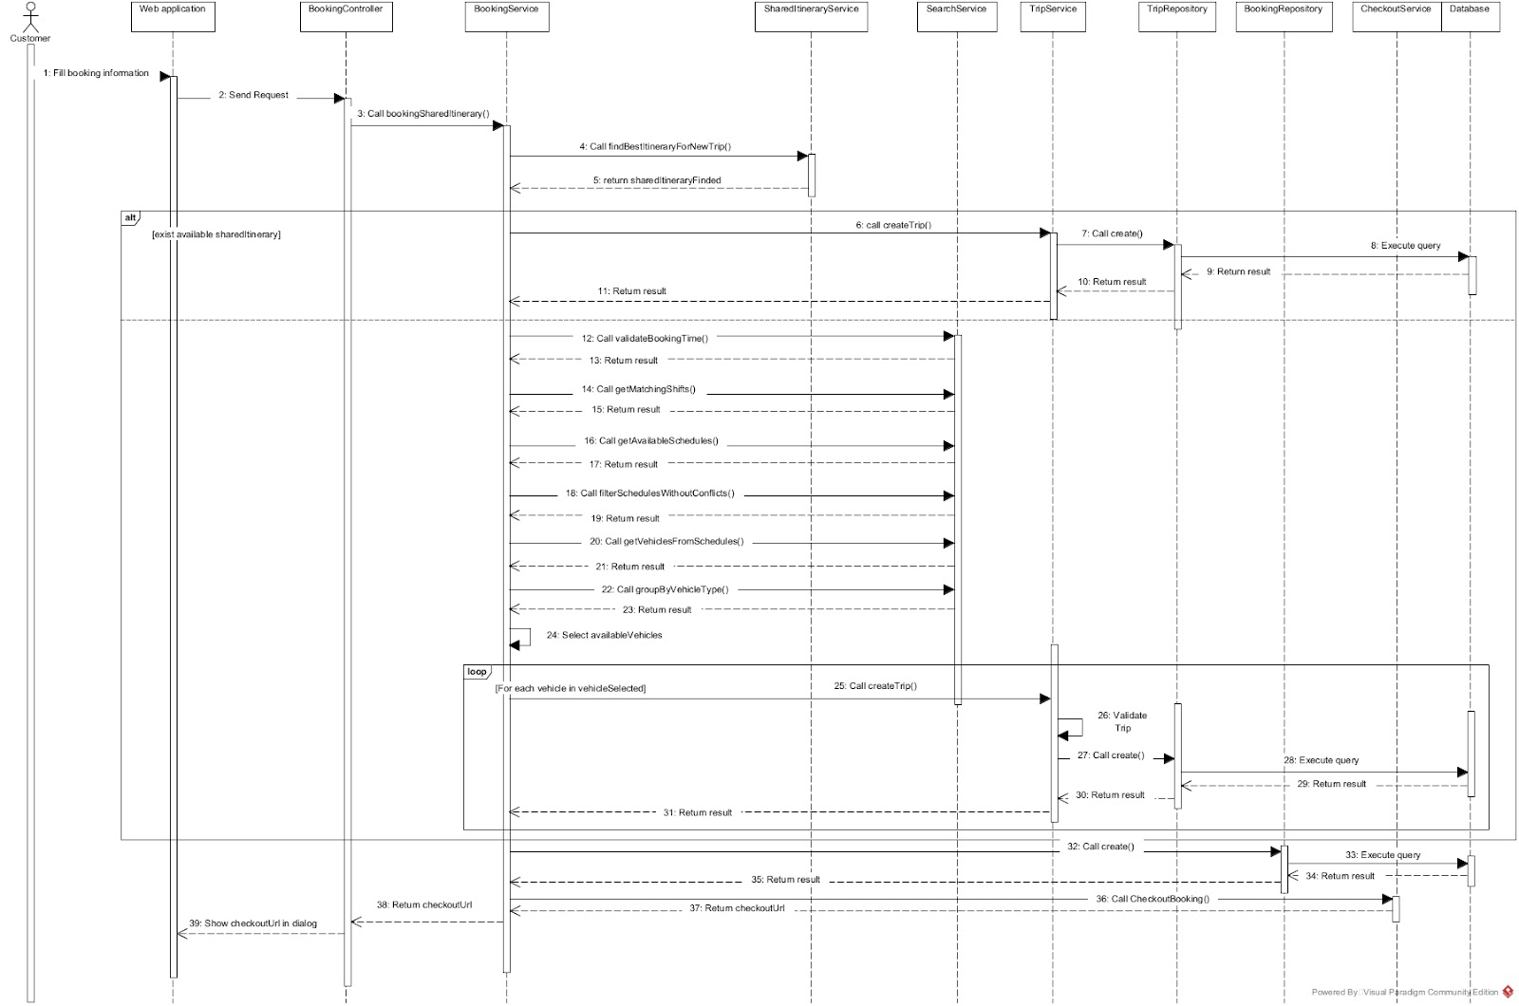

3.2.6 Checkout Booking Sequence Diagram
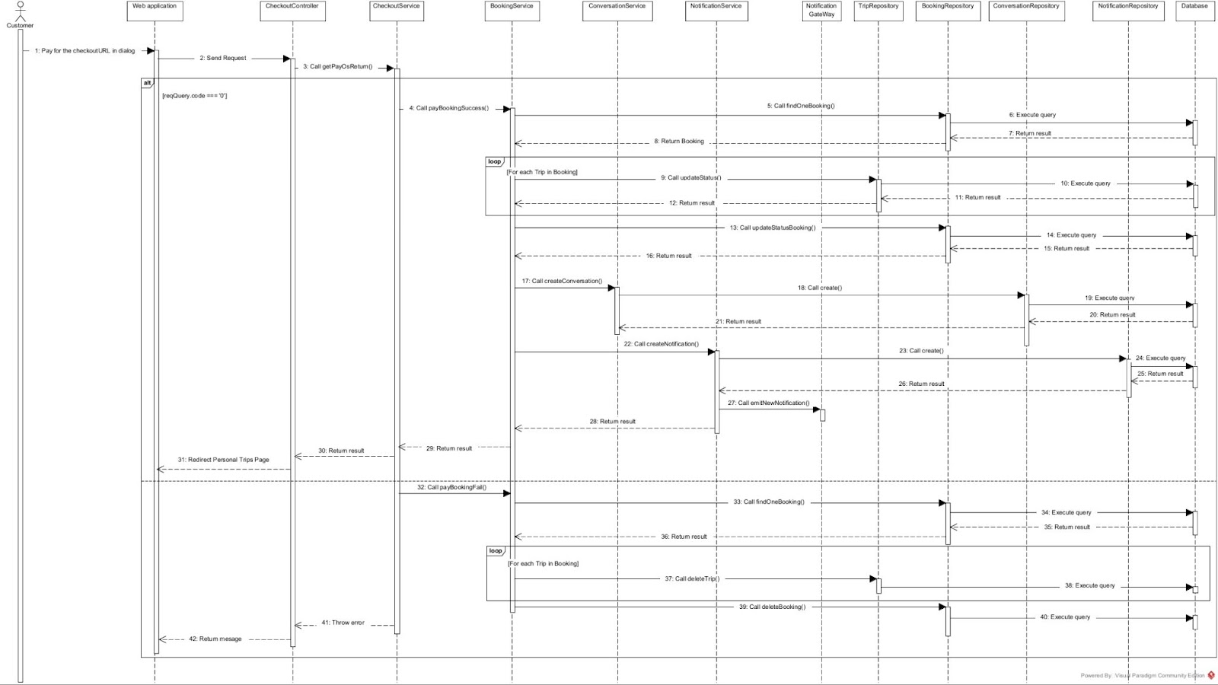

3.3 Manage Trip

3.3.1 Trip Class Diagram
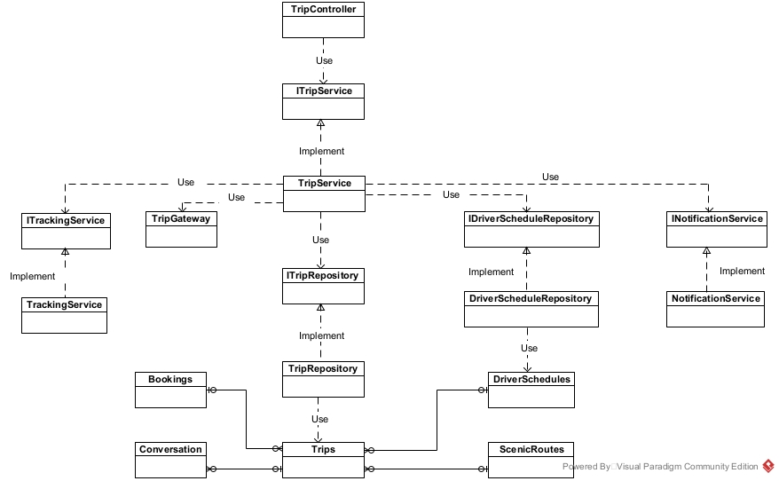

3.3.2 Driver Execute Trip Activity Diagram
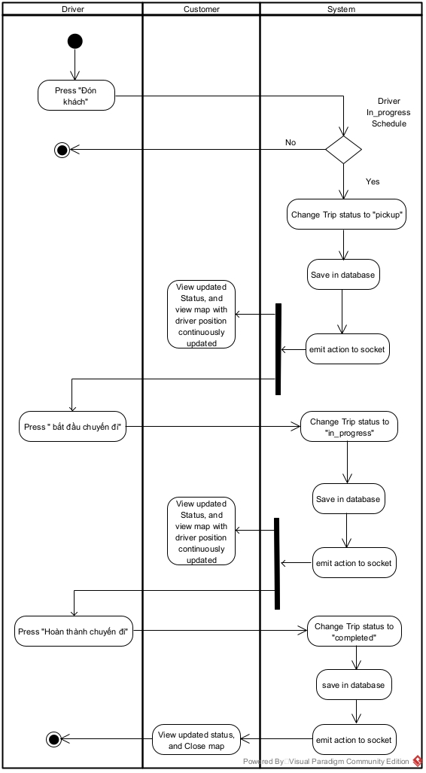

3.3.2 Driver Pickup Trip Sequence Diagram
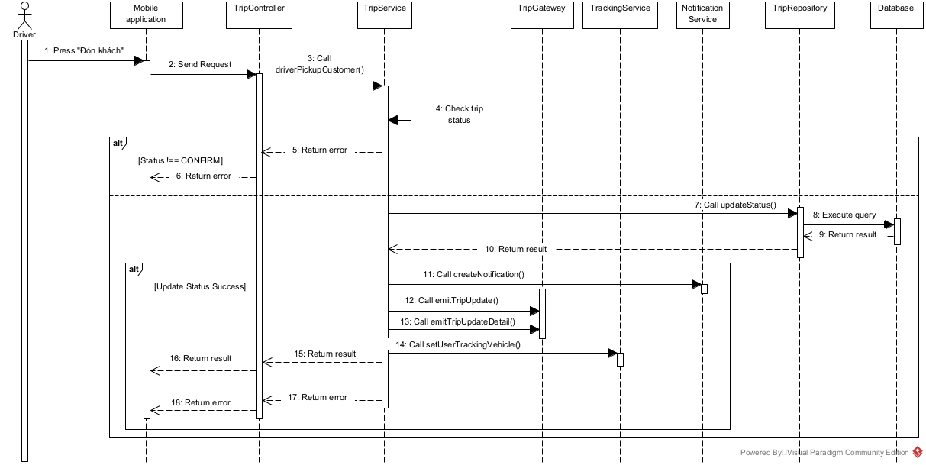

3.3.3 Driver Start Trip Sequence Diagram
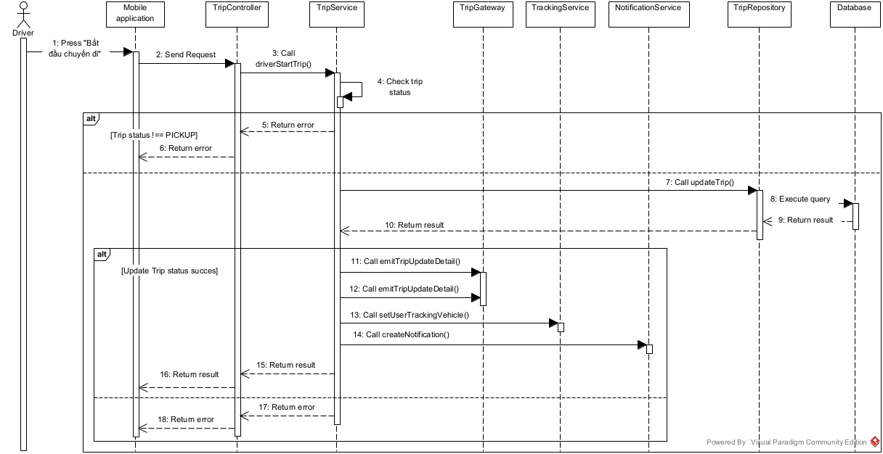

3.3.4 Driver Complete Trip Sequence Diagram
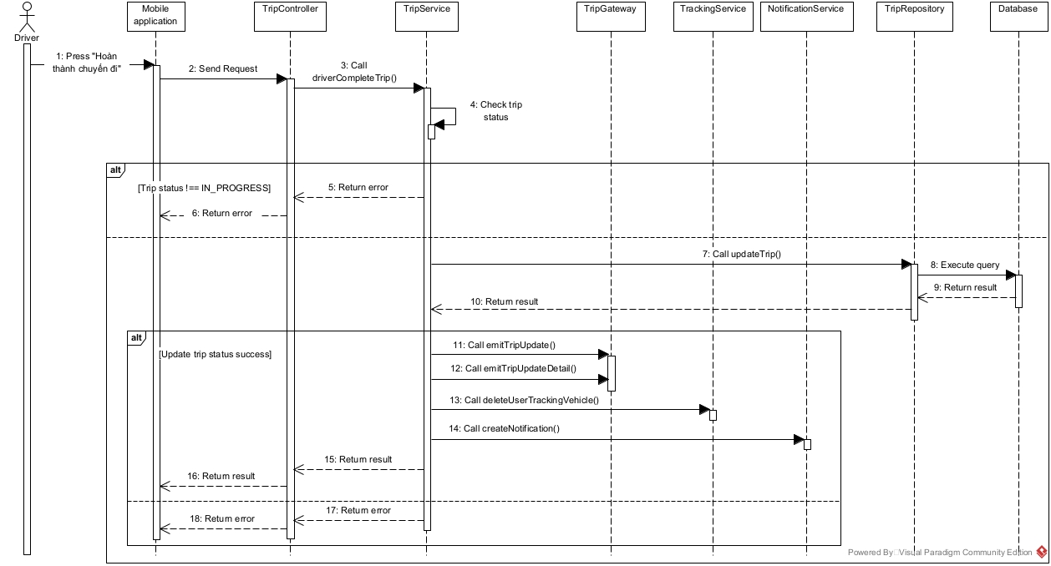

3.3.5 Cancel Trip Sequence Diagram

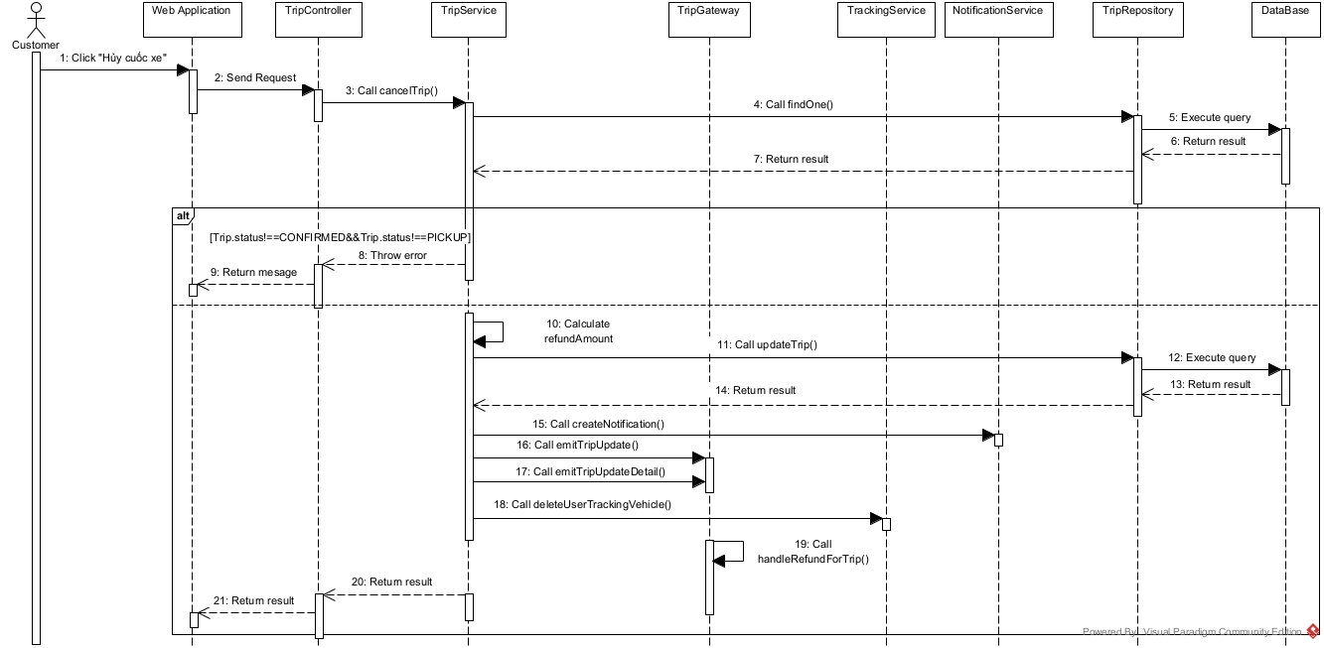

3.3.6 Tracking Vehicle Sequence Diagram
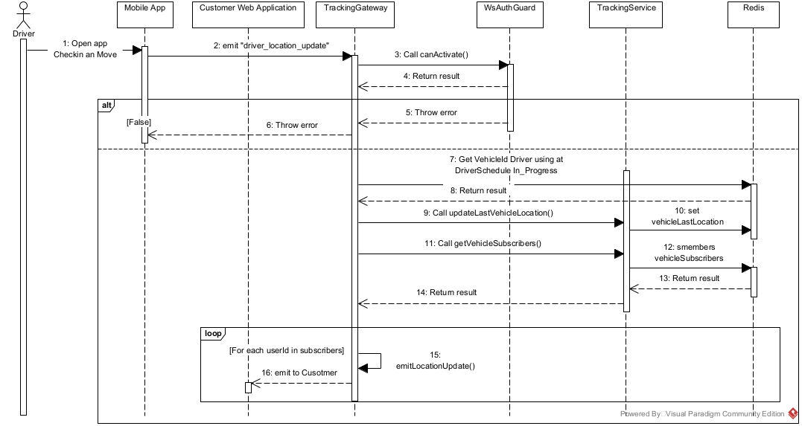

3.3.5 Trip State Machine Diagram
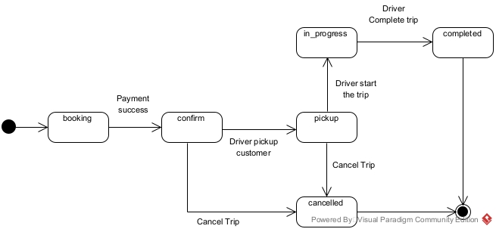
3.4 Manage DriverSchedule
3.4.1 DriverSchedule Class Diagram

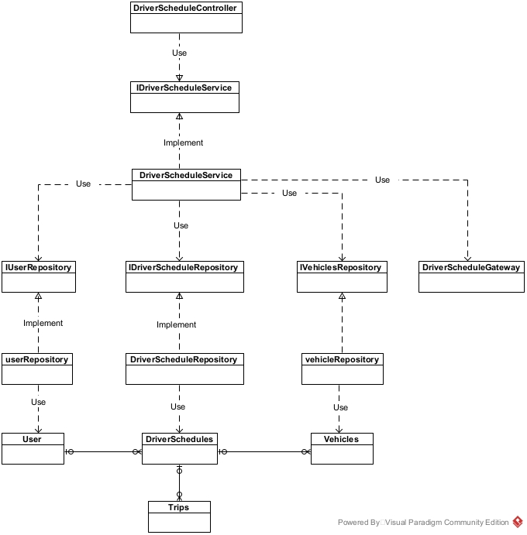

3.4.2 Create DriverSchedule Sequence Diagram

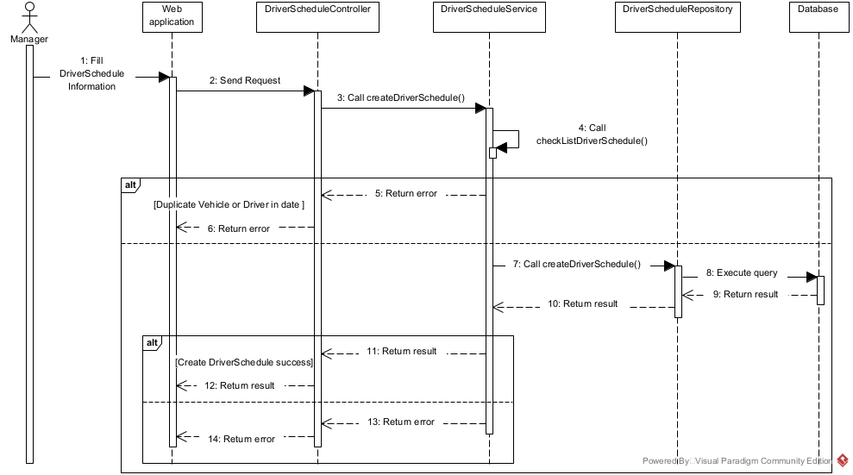

3.4.3 Update DriverSchedule Sequence Diagram

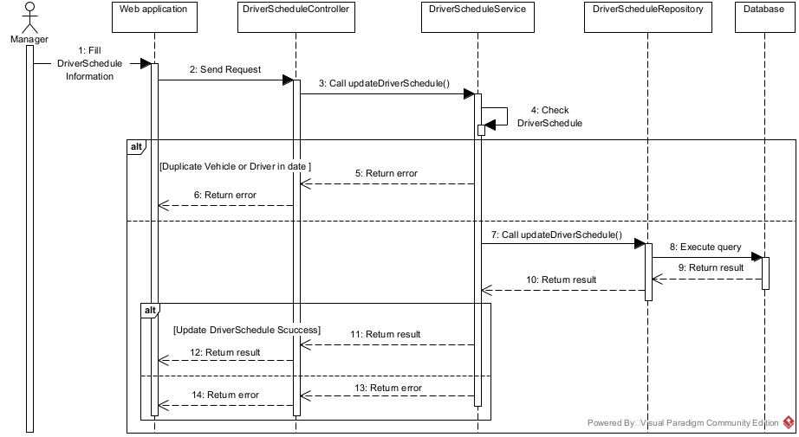

3.4.5 Driver Checkin DriverSchedule Sequence Diagram
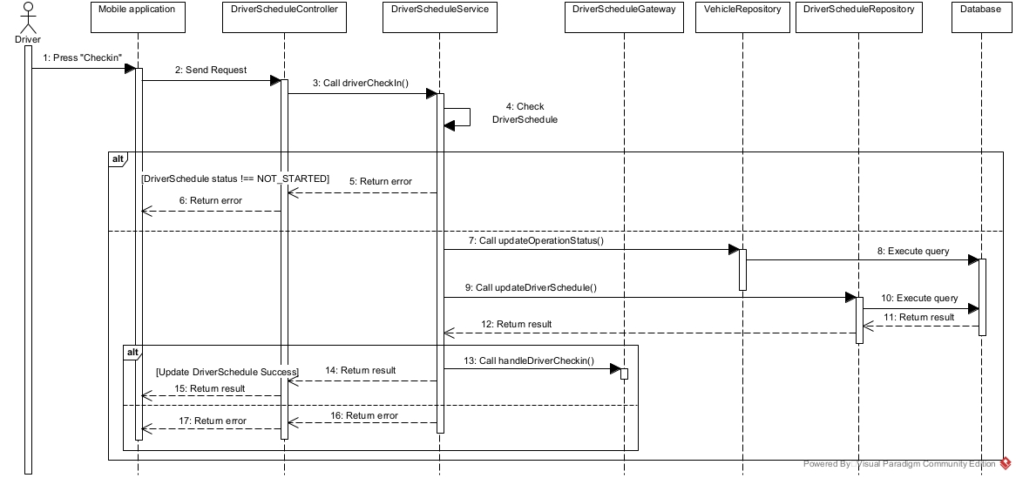

3.4.6 Driver Checkout DriverSchedule Sequence Diagram

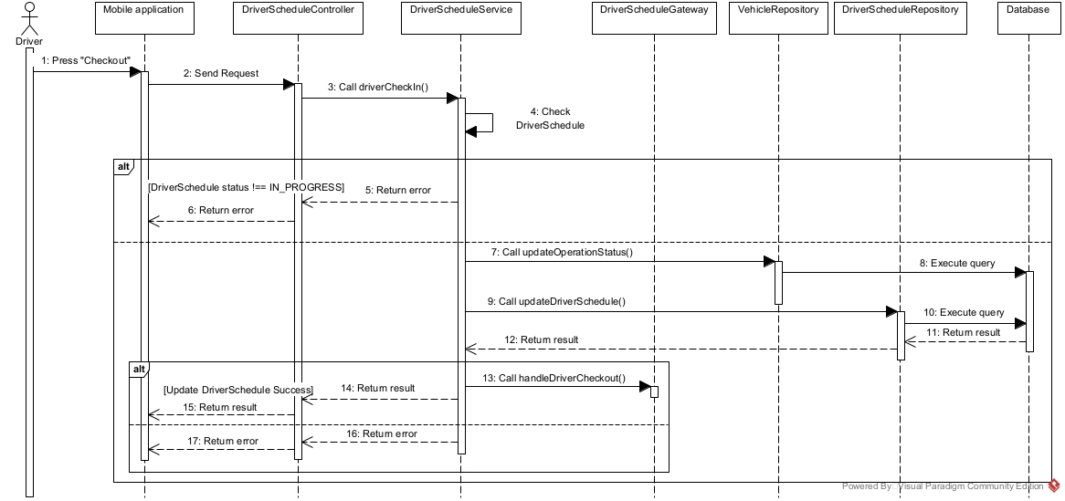

3.4.7 DriverSchedule State Machine Diagram
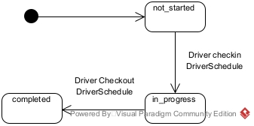

3.5 Manage ScenicRoute

3.5.1 ScenicRoute Class Diagram
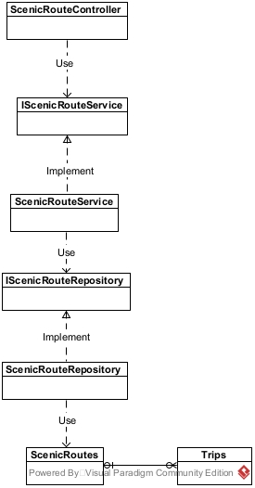

3.5.2 Create ScenicRoute Sequence Diagram
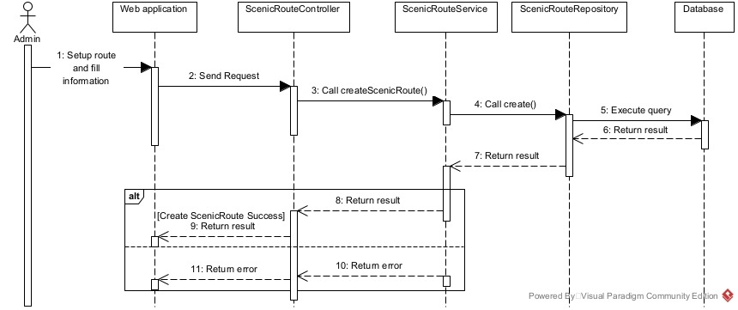

3.5.3 Update ScenicRoute Sequence Diagram
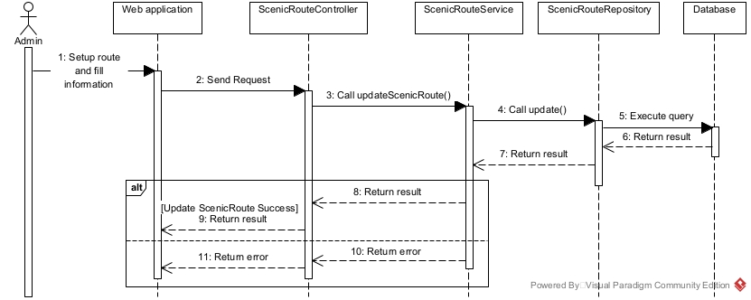

3.5.4 ScenicRoute State Machine Diagram
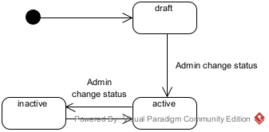

3.6 Manage Vehicle

3.6.1 Vehicle Class Diagram
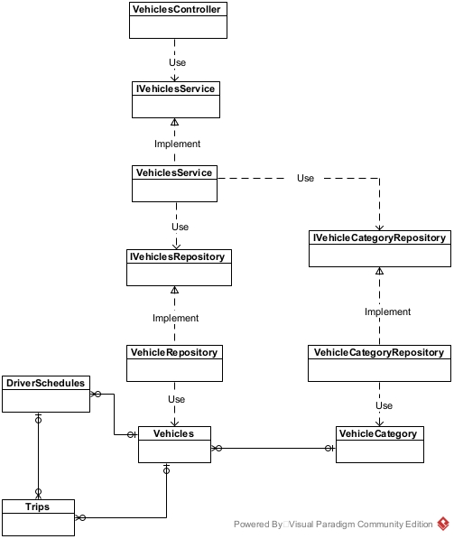

3.6.2 Create Vehicle Sequence Diagram

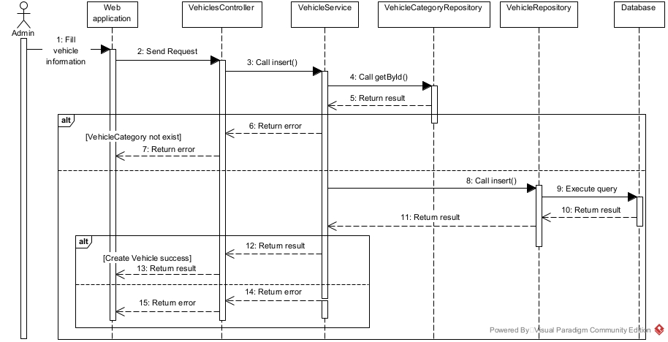

3.6.2 Update Vehicle Sequence Diagram
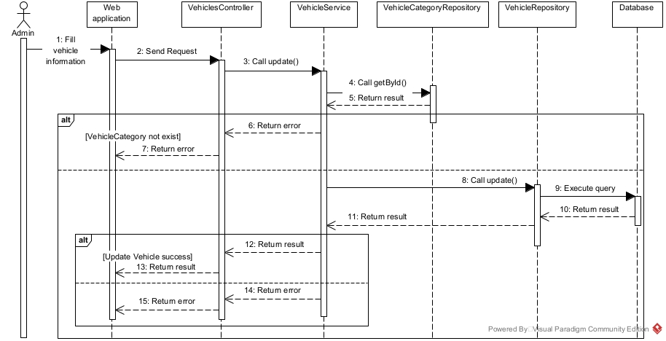

3.6.3 VehicleCondition State Machine Diagram
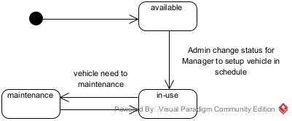

3.6.4 VehicleOperationStatus State Machine Diagram
